Good Shepherd
Catholic School
Educating Today's Students To Be Tomorrow's Leaders

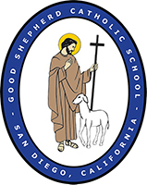

COVID-19 Safety Plan (CSP)

for the 2021-2022 School Year

Link to COVID-19 Prevention Plan (CPP)

It’s impossible to plan for every scenario we may face in 2021-2022.
Our staff will receive continuous training and families will continue to receive information as updates occur.

Information regarding reopening schools is being updated often by authorities. Please note that these policies and procedures are based on guidance from the San Diego County Office of Education, the California Dept of Health Mask guidance, the CA Department of Education, the Center for Disease Control, the San Diego County Public Health Order, the American Academy of Pediatrics, and the Diocese of San Diego. All policies will be updated as new information is gathered and can be found on the Good Shepherd Catholic School website’s home page.

Please note: If San Diego County closes down again, schools will not necessarily close. Stay tuned to school communications for updates.

Good Shepherd Catholic School (858) 693-1522
Principal: Mrs. Ladonna Lambert
Asst. Principal: Mrs. Mary Ann Thiebach
Good Shepherd Catholic Church (858) 271-0207
Pastor: Fr. Michael Pham

Table of Contents
Section I: General Health & Safety Guidelines | 3
Screening for Symptoms at Home | 3
Arriving and Screening Procedures | 4
Sick Student Guidelines | 5-7
Sick Staff Guidelines/Physical Distancing | 7
Face-Covering Policy | 8
Contact Tracing | 8
Travel Policy | 9
Dismissal Procedure | 9
Visitors/Volunteers | 10
Lunch Policy | 10
School Closure Guidelines | 11
Schoolwide Communication | 11
Section II: Physical Distancing on Campus | 12
Classrooms & Learning Platforms/Stable Cohorts | 13
Schedules | 13
Lunch/Recess/PE/Aftercare | 13
Supplies/Technology | 13
Section III: Catholic Identity | 14
Mass Procedure | 15
Section IV: Cleaning & Sanitization Procedures | 15
Daily Cleaning Procedures | 15
Section V: Instructional Model | 16
Independent Learning | 16
Section VI: Resources | 16

Section I: General Health & Safety Guidelines

The health and safety of GSCS’s students, teachers, and families is our first priority. Therefore, the following procedures will be in place beginning the first day of school until further notice (and are subject to change in accordance with state and local policies mentioned above).

1. Screening for symptoms at home
We strongly encourage all parents to screen their children at home for signs of symptoms or illness PRIOR to coming to school. This will reduce the number of times you will be asked to keep your child at home, as the guidelines around symptoms and illnesses are very strict at this time. To screen your child prior to school arrival, please check the following:

Fever with or without chills (100℉ or higher that doesn’t resolve within 30 minutes without medication)
Cough
Shortness of breath
Muscle or body aches
Headache
Sore throat
New loss of taste or smell
Nasal congestion or runny nose
Nausea, vomiting, or diarrhea
Fatigue
Poor feeding or poor appetite
Contact with any person who has tested positive for COVID-19

Vietnamese Tagalog Spanish Chinese
If you keep your child at home due to illness or exposure to COVID-19, you are obligated to call and inform the school of their symptoms (if any) and if they have been seen by a doctor. Students require proof of a negative COVID-19 test to return to GSCS.

2. Arriving and Screening Procedures
If your child is healthy and ready to come to school, these are the policies and procedures in place to keep students, teachers, and families healthy and safe.
- School drop-off will occur between 7:30 - 7:45 a.m.
- Late arrivals (after 7:45 a.m.) will enter through the front office.
- Teachers will be ready for students in their classrooms at 7:30 a.m.
- Two drop-off zones are available:
Grades 3-8 Back gate/parking lot - Drive by the gym to drop-off student(s) in the
back parking lot where staff members will assist the student(s) inside their car
and check for mask-wearing. Students will then go directly to class.
Preschool,TK, Kindergarten & 1st & 2nd grade - Enter at the side gate by the bathrooms/church parking lot. Students will sanitize hands when
entering class. Parents will be able to walk their child to the side gate and students will walk to class.
⚕️

GOLD COAST DRIVE

Preschool,TK,Kinder., Grs 1
& 2
Grades 3-8
drop-off

infant entrance
1
2
K
TK
Preschool

All parents who come on campus will have to wear a mask whether or not they are vaccinated.

Students will be screened for signs and symptoms of COVID-19. Parents will be asked if anyone at home is experiencing signs, symptoms, or has been in close contact with someone with COVID-19. At least one parent/guardian MUST REMAIN with each student at the screening station until the student has been cleared.
- Families must maintain 6 feet distance from other families and wear masks at all times, to ensure the safety and health of our GSCS community.
- If a student (or anyone at home) exhibits any of the signs, symptoms, or has had close contact (>15 min. cumulative exposure within 6 feet in 24-hours) with COVID-19, the student will be required to return home.
- If a student does not pass the health screening, a parent/guardian must take the student home and keep the school informed of symptoms. Refusal to comply with the sick policy will result in a meeting with administration and potentially result in consequences up to and including expulsion from the school.

3. Sick Student Guidelines
The following are the guidelines for health screening students either at school arrival or if they fall ill during the day:
- Fever with or without chills (100℉ or higher that doesn’t resolve within 30 minutes without medication)
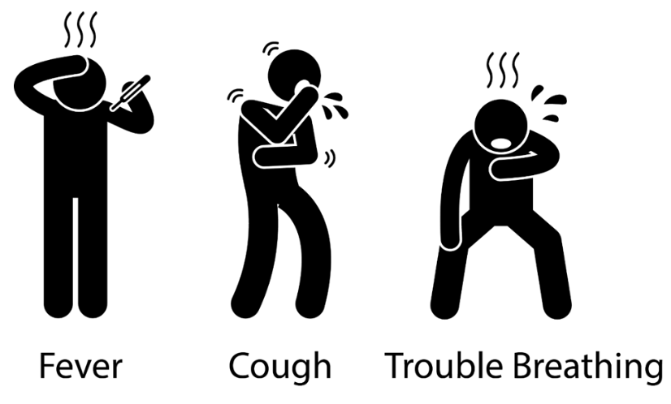
- Cough
- Shortness of breath
- Muscle or body aches
- Headache
- Sore throat
- New loss of taste or smell
- Nasal congestion or runny nose
- Nausea, vomiting, or diarrhea
- Fatigue
- Poor feeding or poor appetite
- Contact with any person who has tested positive for COVID-19

If a student exhibits any of these symptoms at the arrival screening or during the school day, the student will be isolated comfortably in the health room, and a parent/guardian MUST take him/her home as soon as possible.

If a student or staff member has a fever of 100℉ or higher, a doctor’s note and/or negative COVID-19 test must be presented to the school office prior to re-entering the classroom any earlier than the 10 day isolation period (24 hours without fever or fever-reducing medications, symptoms are improving, AND at least 10 days from symptom onset or test date).
Students will pivot to Independent Learning while at home. Staff members will contact their primary physician or 211 for COVID-19 testing and continue Independent Learning if a class is closed.
If a student or staff member tests positive for COVID-19 and has exposed others at school, the following will take place:
- In consultation with the local public health department, it will be decided whether a school closure is warranted, including the length of time necessary, based on the risk level within the specific community as determined by the local public health officer.
- The GSCS community will be notified within 24 hours of the school knowing of any positive COVID-19 case while maintaining confidentiality, as required by state and federal laws.
- The room where the patient was located will be closed-off while it is cleaned by cleaners trained in accordance with public health guidelines.
- Additional close contacts at school outside of the patient’s classroom/office should also self-isolate.
- Additional areas of the school visited by the COVID-19 positive patient may also need to be closed temporarily for cleaning and disinfection.
- If a school closure happens, all members of the community should maintain social distancing, avoid gatherings, and follow any additional CDC guidelines.
What measures should be taken when a student, teacher or staff member has symptoms, is in contact of someone infected, or is diagnosed with COVID-19?

Decision Tree (Updated 8/11/21)

When quarantine is required:
Modified 10 day (stay at home): Independent Learning
Return on Day 11 is permitted with COVID testing for asymptomatic symptoms.

If a child has an identified condition that will result in a positive screening (i.e. allergies, eczema, migraines, asthma, etc.), a doctor’s note will be accepted to return to school prior to the 10-14 day COVID-19 guidelines if symptoms are in line with identified conditions. *It is helpful to alert the office at the beginning of the year if a child has an identified condition, as mentioned.*Without the note, your child will be sent home due to COVID-19 like symptoms.

4. Sick Staff Guidelines & Vaccination/Physical Distancing
Teachers and staff will be held to the same health guidelines stated above in the student section to reduce transmission between adults.
- Teachers are encouraged to self-screen at home prior to coming to school.
- Upon arrival at school, teachers will submit to a temperature check, and health screening using the questionnaire to assess signs, symptoms and contact with COVID-19. They will be sent home immediately if their temperature is 100℉ or above, they identify signs, symptoms or have had contact with COVID-19 positive patients.
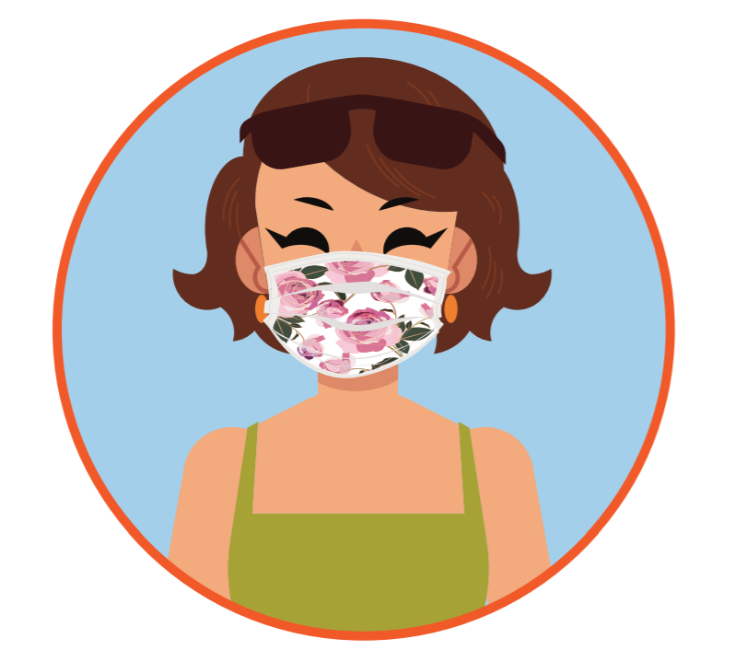
- Teachers and staff have dedicated work areas that are separated with at least 6 feet of distance at all times. Staff meetings are held virtually or socially distanced in a large classroom.
- If throughout the day, a teacher or staff member develops a fever or any symptoms, he/she will be immediately isolated then sent home. Areas used by anyone suspected of being infected will be closed off for 24 hours prior to cleaning and disinfecting.
- Staff testing for asymptomatic infections will occur as test availability permits, or is practical through their primary physician, or through the county (211). All staff will be tested once every 2 months (with 25% of staff tested every 2 weeks). Additionally, Flu shots are highly encouraged.

5.Face Covering Policy
All staff and students are required to wear a cloth or 3-ply disposable mask (or N95 for school nurse) at all times on campus. They can be removed when eating and drinking. (No valve masks are allowed.)

Face shields can also be worn with masks for extra protection, if preferred.
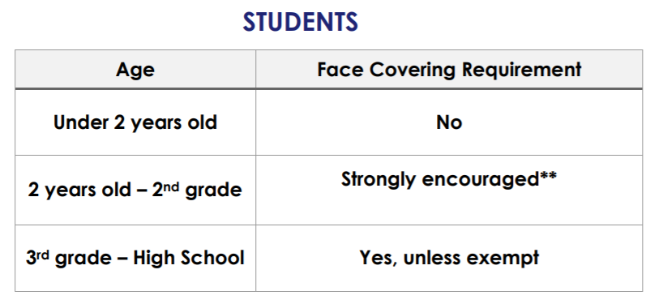
Yes, unless exempt

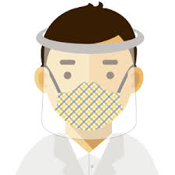
Mask breaks are no longer allowed. Masks should only be removed when eating or drinking. Masks should then be placed in a paper bag or baggie for safe keeping.

All students will be provided with 2 cloth face coverings from the school. They are allowed to bring their own from home, as long as they are school appropriate. The school will have disposable face masks available if a child forgets to bring theirs and they will receive it at the arrival screening station.
**All cloth face coverings should be washed
daily before using again the next day.**

6. Contact Tracing
The school community will be notified if we are made aware of any positive COVID-19 cases on campus, while still maintaining confidentiality per FERPA law. GSCS office staff will monitor absenteeism and types of illnesses/symptoms among staff and students to help isolate quickly. Our staff liaison, Doan Hoang can be reached at (858) 693-1522 or at dhoang@goodshepherdcatholic.net. She is trained to document and trace possible exposure to COVID-19, and communicate responsibly with local health authorities, staff, and community in a prompt manner.

7. Travel Policies
As of now, GSCS students will not be taking field trips or using school buses. If a student or staff member travels outside of the country, they are required to inform the principal.
- If a student or staff member traveled internationally in the last 14 days, they are required to stay home, monitor their health, and practice social distancing for 14 days after returning from travel. Social distancing means staying out of crowded places, avoiding group gatherings, and maintaining distance (approximately 6 feet or 2 meters) from others when possible.

If a student or staff member travels more than 120 miles from their home, they must quarantine for 10 days and/or take a COVID Test after day 5 and submit negative results:
- Practice social distancing
- Be alert for symptoms
  - Watch for fever, cough, shortness of breath, and other symptoms of COVID-19
  - Take temperature if symptoms develop
- Follow CDC guidance if symptoms develop
- Provide school office with negative COVID-19 result after 5 days in order to return to class
The GSCS community would appreciate prompt communication of any travel, as well as symptoms or exposure to COVID-19, directly to the office.
8. Dismissal Procedure
The following procedures are in place to keep students, teachers, and families healthy and safe during dismissal. Following these procedures will reduce the number of students leaving campus at the same time.
- Dismissal will occur between 2:30 and 2:45 p.m., and between 11:45 a.m. and 12:00 p.m. on minimum days.
- Teachers will bring classes (grades 3-8) to the grass field by grade
- Grades TK-2 will stay inside until their names are called
- Students attending Extended Care will report to the gym (Extended Care location)
- Students will remain at least 6 feet apart with masks on
- Three pick-up zones are available:
Grades 3-8 Back gate/parking lot - Drive by the gym to pick-up student(s) in the
back parking lot where a staff member will ask for the student(s) name and
make a call on the walkie-talkie. The student’(s) name will be announced.
Student(s) will sanitize hands prior to leaving school. Masks must remain on until
students leave campus.
Preschool -Gr. 2 Pick-up student(s) at the side gate. Please wear a mask and remain 6 feet apart. Students will remain in classrooms until called. Students will sanitize hands prior to leaving school. Masks must remain on until students leave campus.

*Rainy Days: All students will remain indoors on rainy days until their
names are called, and the student will proceed to the back lot or side gate.
Please remember to wear a face mask when picking up your student(s) and maintain 6 feet of distance between other GSCS community members. If driving through to pick-up, please wear a mask when speaking with GSCS staff. We request your patience as students will need time to sanitize their hands once called to a pick-up location.
Students will not be able to return to classrooms for forgotten items. If there is an immediate concern (such as something valuable or an item required for homework practice) please email the teacher so he/she is aware.
9. Visitors/Volunteers
Visitors/Volunteers have to check in the front office. Unfortunately, volunteers will not be able to assist in the classroom.
In the interest of health and safety, appointments can be made with teachers/administrators via Zoom or phone call by contacting them individually. If an in-person appointment is necessary and scheduled in advance, visitors must check-in at the front office to be screened by having their temperature taken and identifying signs, symptoms, or contact with COVID-19. All parties will be required to wear a mask, sanitize hands, and maintain 6 feet physical distance at all times.
10. Lunch Drop-Off Procedure
This year, it is highly suggested that students come to school with their lunches already packed. Student belongings will be stored in/outside of student classrooms.
If a student forgets his/her lunch, a lunch can be dropped off at the front office. A table will be available outside. Please clearly label the bag with the student’s name and grade. Lunches will be picked up prior to lunch and delivered to the student’s designated eating area. For sanitation purposes, food and drink items should be sealed shut (ex.no straws sticking out).
Healthy lunches are encouraged. The American Academy of Pediatrics recommends that children consume a good balance of foods from the five major food groups: vegetables, fruits, grains, protein and dairy. Fast food/extra sugar should be limited.
11. School Closure Guidelines
GSCS will follow all local public health and the Diocese of San Diego guidelines and requirements when it is necessary to temporarily close the campus (see more details in #3 above).
12. Schoolwide Communication
The GSCS office is open daily from 7:30 a.m.-3:00 p.m., and 7:30 a.m.-12:00 p.m. on minimum days, unless otherwise stated. The front office staff is available to answer questions, provide information, or help in any way we can via phone or email.
Office phone # (858) 693-1522 / Email: dhoang@goodshepherdcatholic.net
Information will be communicated in a timely fashion the following ways:
- Ongoing detailed information via Schoolspeak (use family username and password on GSCS Student Information Sheet to login)
- Ongoing general information via GSCS website
- Weekly or as needed via e-envelope
- Administration newsletter

Administration is available for conferences via Zoom or in-person by appointment only. Questions are welcome via email and will be replied to within 24 hours.
Monday morning assemblies will take place in the courtyard.

Section II: Physical Distancing on Campus

This section is provided to give families an idea of how learning physically takes place on campus. All plans follow health guidelines and policies while allowing students to learn, play, and grow as children of God.
1. Classrooms/Learning Platforms/Stable Cohorts
Students will remain with their grade-level classmates for all subjects except PE. When feasible and appropriate, teachers may choose to teach a lesson outdoors.
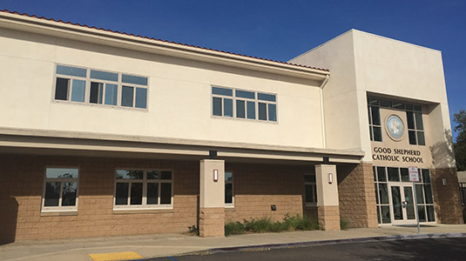
Teachers are equipped to deliver a blended learning model within this framework and will institute opportunities for collaboration within these limits. Teachers will maintain appropriate distance from students for their safety but will adhere to the students’ social, emotional and academic needs first.

2. Schedules
Students’ schedules have been designed to decrease contact with students outside of their grade-level class. Recess and lunch breaks in designated locations, as well as clearly posted walking traffic patterns, will decrease possibilities of interaction. Although part of our mission is to empower our students through the teachings of Jesus Christ to evangelize in love and service, we will challenge students to create new ways to form bonds with one another amongst various grade levels through the use of old-fashioned gestures of friendship. We pray this situation is temporary and know that we will come through together as a community.
3. Lunch/Recess/PE
Each class will wash hands prior to lunch and recess. Face coverings will be worn to and from recess and lunch. Face coverings can be removed while eating. Students will have recess in their designated spot.
Minimal equipment will be available and sanitized after each use. Students are encouraged to play low impact, non-contact activities. After recess, students will wash their hands prior to returning to class.
*Sorry, no food can be shared (including birthday/celebration treats).
Students will wash their hands first and sit apart at their designated spots. Students will wash their hands before playing or returning to class. The area will be wiped down thoroughly in preparation for the next class.
PE will take place indoors or outdoors once per week, weather permitting. Classes will no longer be combined or change uniforms at school. Masks will be worn, and any equipment will be sanitized prior to use by another student and will not be shared.
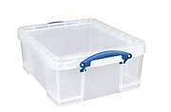
4. Before/After School Care
Students will need to bring their own supplies in a plastic bin for Before/After School Care. The students will play separately or remain at an assigned desk to do their work.
5. Supplies/Technology
It is important that each student has access to their own supplies, due to health concerns. Students will be required to keep backpacks on the back of their chairs. All supplies should be housed in a container that is conducive to the teacher’s classroom plan (see supply list or email teacher for further information). If for some reason a supply must be borrowed from the school or teacher, it will be sanitized before and after use.
Chromebooks or tablets will be assigned to each student. Students and families will sign a Technology Agreement committing to take care of the device for the duration of the school year and report any damage or loss immediately to the teacher. Students will bring their devices home daily, charge, and return them daily. Additional charging stations will be available in all classrooms. Regular cleaning/disinfecting is encouraged at home.

Section III: Catholic Identity
At the heart of Catholic education there is always Jesus Christ. GSCS endeavors to build a community that is Christ-centered within an atmosphere of love, mutual respect, and cooperation so that students can grow in human dignity and hope, where parents and members of the parish will feel a spirit of Christian hospitality in their interactions with the school.
Mass:
- Students will attend a weekly 8:30 a.m. indoor Mass with our parishioners.
- Students will be cohorted by grade level, socially distanced, and required to wear a face covering. Families are welcome to attend these weekly Masses but are asked to sit apart from the students.
- Liturgy/dress uniform must be worn on days the liturgy is celebrated. Students are encouraged to wear sunscreen and a hat as needed.
- Persons in attendance at Mass must follow the instructions given by parish and school personnel for the safety of our students and staff members.
- Students who remain in Distance Learning will be able to celebrate the Mass from home via livestream.
Prayer:
- Monday morning assembly will be livestreamed for viewing from home and prayed over the PA system.
- Prayer before meals and The Angelus will be prayed over the PA system daily.
- Students will be given the opportunity to pray the Rosary every Monday from 2:45-3:30 p.m. in the Marian Courtyard. Students will be socially distanced during prayer.

Service:
We will provide students with virtual and in-person opportunities to use critical thinking skills to develop moral responsibility to do good works in society. This Christian service outreach will allow students and their families to put faith into action.

Family:
We thank you for your commitment to excellence in Catholic education and allowing us to partner with you in laying the foundation for spiritual and academic achievement through a real encounter with Jesus Christ. We will offer ongoing education and support to practice Faith at home. Our clergy, administration, and staff will provide enhanced opportunities for community building through prayer, discussion, and reflection.

Section IV: Cleaning & Sanitization Procedures
This section outlines the various ways everyone will work together to ensure our campus remains a safe place where our community can teach, pray and learn together.

1. School cleaning and sanitization
- All carpets and floors have been professionally cleaned over the summer.
- Air filter systems have been placed in all rooms.
- Professional cleaning services using EPA-approved solutions for COVID-19 have been increased to clean high touch surfaces throughout the school day, including lunch tables, bathrooms, and handles.

2. Daily student cleaning and sanitization procedures
- Each class will have their own hand sanitizers accessible at all times.
- Each class will be designated their own hand washing center.
- At the end of the school day, each space used by students will be thoroughly sanitized in preparation for the next day by properly trained staff. Students will only be sanitizing their own supplies (within their own storage container) with soap and water.

3. Daily teacher cleaning and sanitization procedures
- Teachers will be responsible for maintaining hand sanitizer and disinfectant supplies by communicating with the office when needs exist.
- Teachers will be responsible for cleaning technology and any borrowed supplies at the end of each school day.
- Cleaning staff will thoroughly disinfect classrooms each day, including high-touch surfaces, student desks, doorknobs, and chairs.

Additional Resources
CDC Resources - Chinese CDC Resources - Tagalog
CDC Resources - Spanish CDC Resources - Vietnamese

Section V: Independent Learning Platform
All students will be learning in person. If we must pivot or if a child is ill/exposed to COVID-19, students will start independent learning with materials assigned by the teacher.

There are a few scenarios where students may need to go to Independent Learning:
- When students show symptoms of COVID-19, become ill, or are self-isolating due to close contact with a COVID-19 patient, they will be able to continue learning from home (if they are well enough to do so).
- Students that travel internationally or more than 120 miles must follow the guidelines stated on page 8 and participate in Independent Learning from home for a limited time.

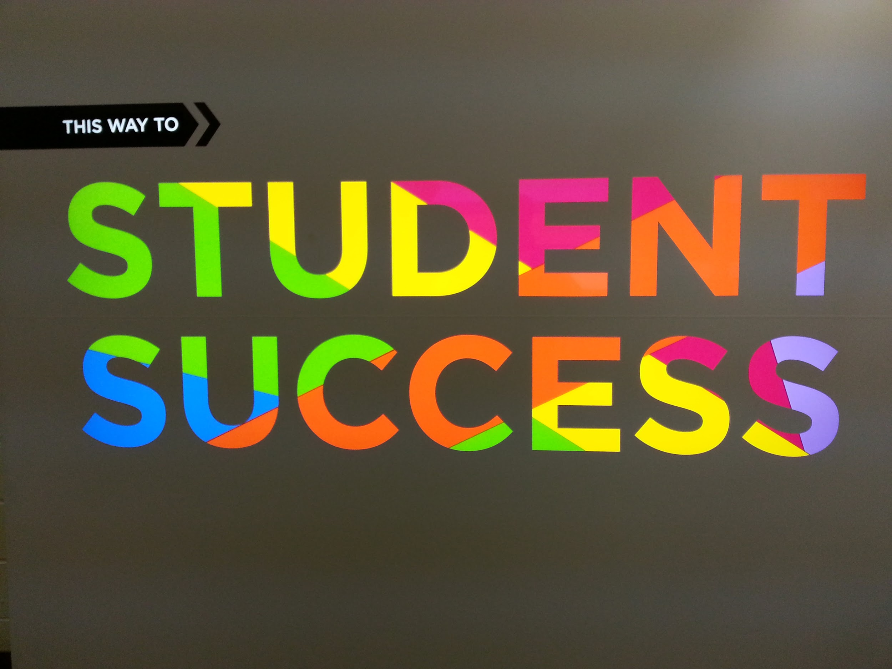
We thank you for your support during these trying times and for entrusting us to provide your children with a high quality Catholic education

Section VI: Resources

Contact Tracing  - How is the state supporting schools with contact tracing  - Quarantine Guidance | General  - Division of the State Architect [Design & construction oversight for schools]  - AB 685 COVID-19 Workplace Outbreak Reporting Requirements | Health and Safety  - California's Safe Schools for All Plan  - Cal/OSHA COVID-19 Prevention Emergency Temporary Standards  - CA COVID-19 Face Covering/Mask Guidance  - Guidance for the Use of Face Coverings  - California's Safe Schools For All Hub  - Safety Guidance  - CDPH Guidance Related to Cohorts  - Cohort FAQ for Providing Targeted, Specialized Support and Services at School  - Reminders for Using Disinfectants at Schools and Child Cares  - Asthma-Safer Cleaning and Disinfecting  - Finding EPA Registered Disinfectants Effective Against SARS-CoV-2
Accessing Local Resources  - COVID-19 Websites for Local Public Health Departments  - Directory of Local Health Departments | Testing  - Testing Resources for Schools
Vaccines  - Vaccinate All 58 | Ventilation  - Ventilation Guidance

